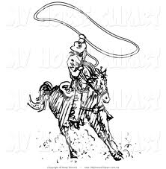
Florence Elementary School Wide Expectations

Cowboys are G.R.E.A.T. !

School-wide  Expectations↓ | Hallway | Cafeteria | Arrival/Dismissal | Bathrooms |  | Playground | Buses
Goal driven | Walk on the right side of the hall and in the right direction. | Will get all needed material before being seated. | Enter and exit Florence in an orderly manner. | Use the bathroom quietly and leave it clean. |  | Play safely in all games and on all equipment. | Remain seated at all times except to get on the bus or off the bus.
Respectful | Walk silently without disturbing other classes. | Speak using “please” and “thank you” to the cafeteria staff. | Follow directions the first time. | Flush  Wash hands |  | Play gently with others by keeping hands, feet and objects to self. | Follow the directions of the bus driver or safety assistant.
Exceptional | Keep hallways free of trash. | Enter/exit in a silent single file line. | Upon entering the school building follow hallway expectations. | Respect other’s privacy. |  | Show good sportsmanship. | Talk quietly and only with those in nearby seats.
Accepting of Others | Keep hands, feet and object to yourself. | Wait patiently when you need assistance. | Keep hands, feet, and objects to yourself | Wait your turn.  Enter and exit bathroom appropriately. |  | Use positive language with peers and staff.  Share equipment. | Keep hands, feet, and objects to yourself.
Trustworthy | Go directly to assigned area. | Speak with inside voice and use kind words. | Get a tardy slip if arriving after 7:50 am | Report unsafe behavior. |  | Stay in designated area. | Remain seated at all times.

